****



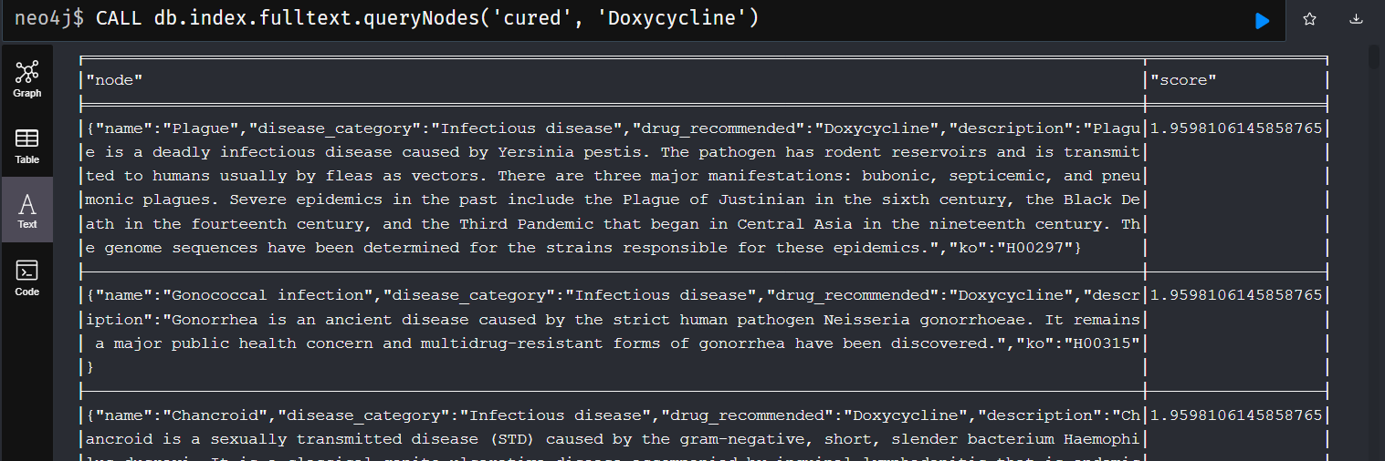

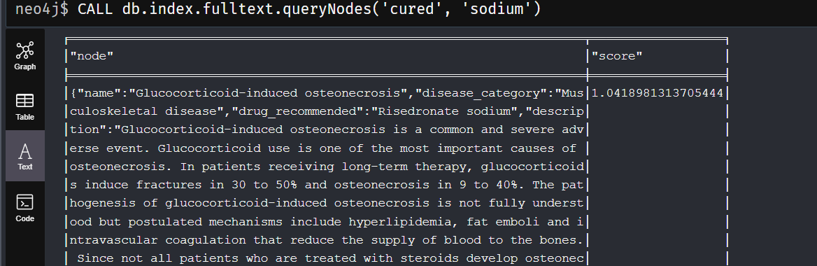

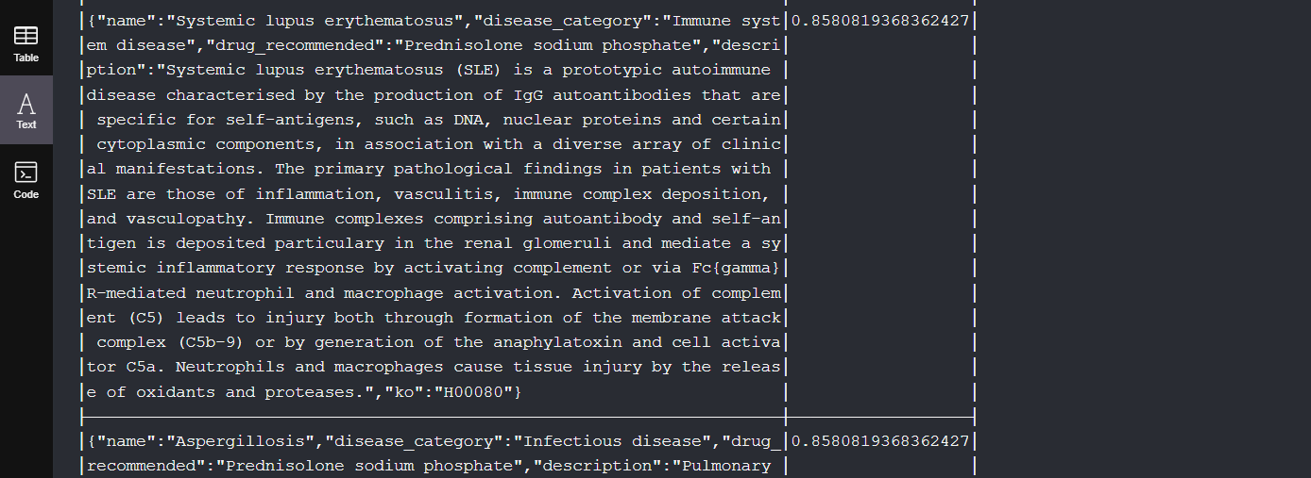

Phrase Query

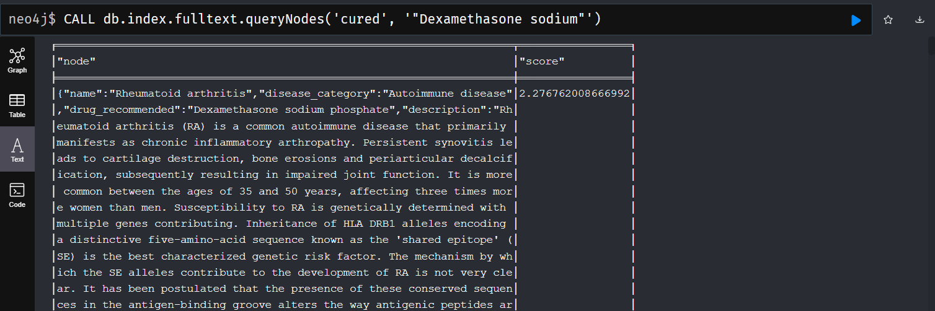

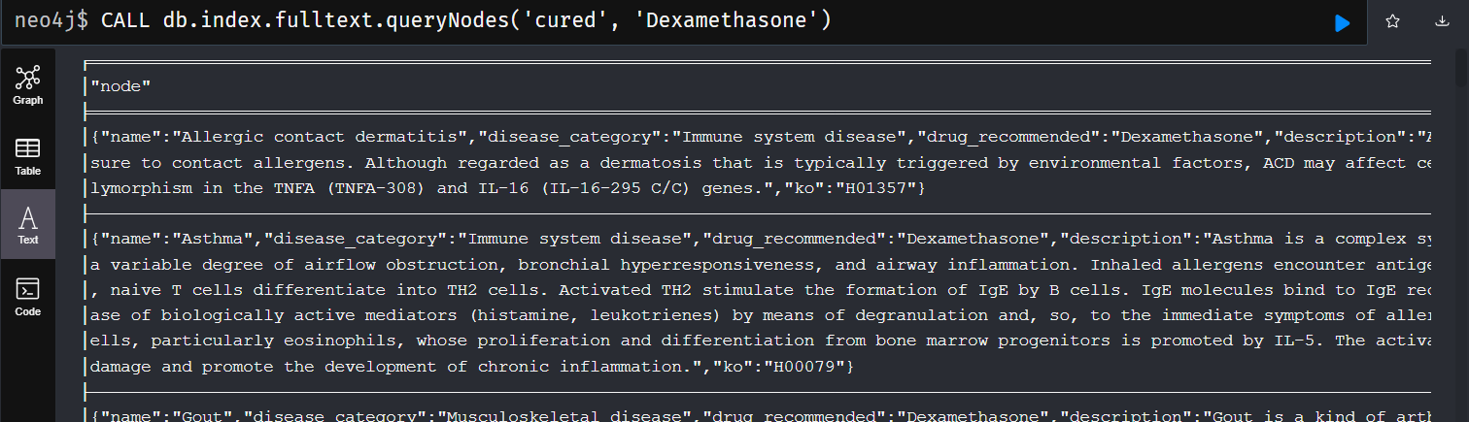

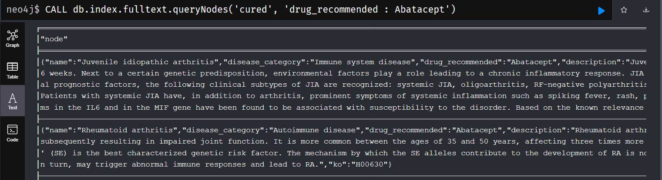

Searching with a specific field

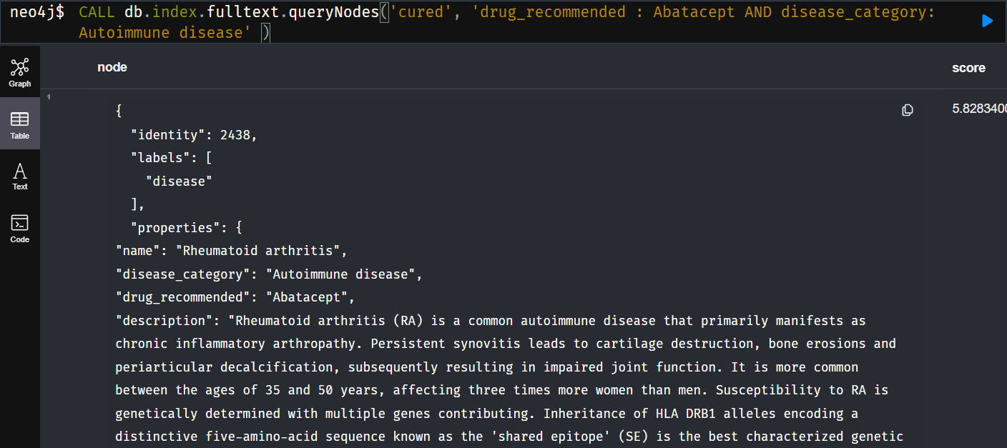

Fuzzy searching

The power of Full Text Search is also the ability to retrieve results even if the search query does not exactly match text in the original corpus.

There are a couple of implementations offering such behaviors, one of them is the fuzzy searching.



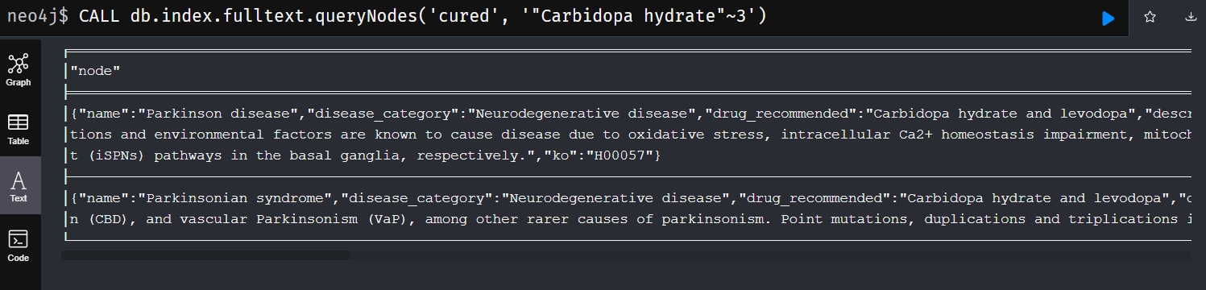

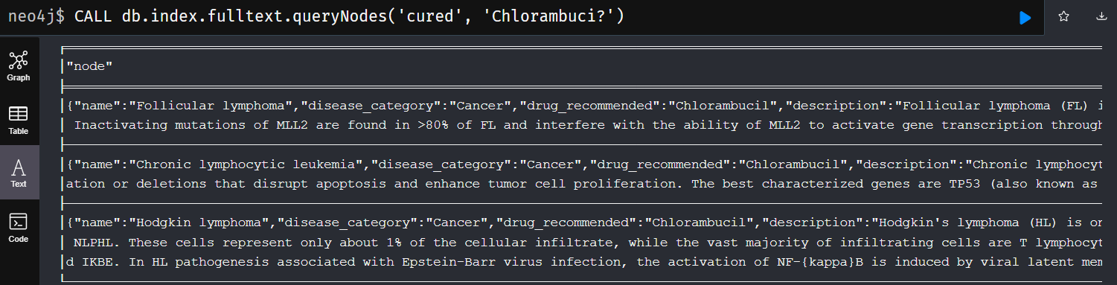

Wildcard query

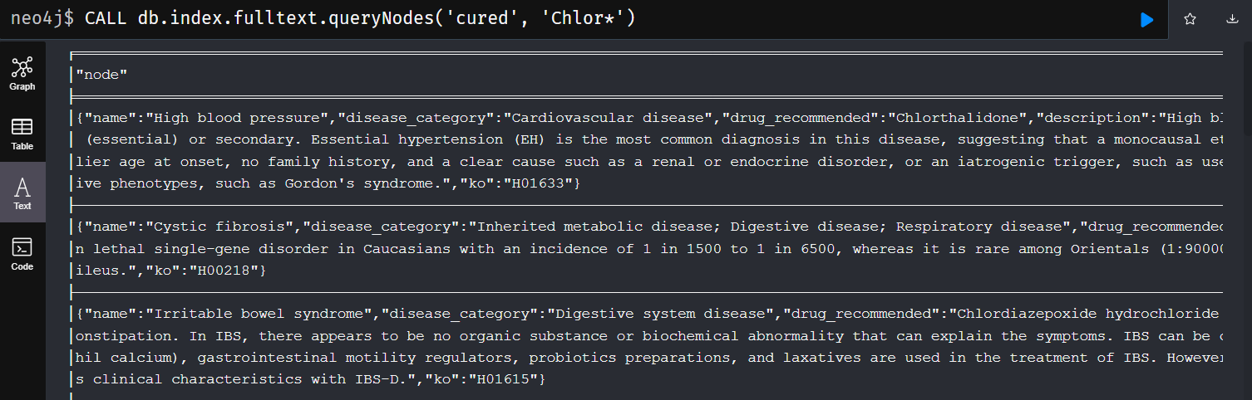

Part -3 WIKIDATA, SPARQL, AND NEOSEMANTICS



